Restaurant Management System

Introduction
James Oliver, a renowned US celebrity chef, owns a chain of restaurants called 'The Grill House' across multiple cities in the United States. To efficiently manage day-to-day restaurant operations, the management has decided to replace the existing manual, paper-based system with a centralized Restaurant Management System (RMS).
This document captures the complete business analysis for the proposed system, including stakeholders, current and future processes, scope definition, and detailed business requirements.

Stakeholder Identification
Primary Stakeholders
James Oliver (CEO): Wants consolidated reporting, customer feedback insights, and overall business visibility.
Restaurant Managers: Manage menu, reservations, billing oversight, reporting, and customer feedback entry.
Waiters: Generate bills, search menu, check table reservation status.
Customers (Dine-in & Delivery): Receive service, pay bills, provide feedback.

Secondary Stakeholders
Kitchen Staff: Receive orders indirectly (future integration possible).
IT/Software Development Team: Build and maintain the system.
Finance/Accounts Team: Use reports for accounting and auditing.
Payment Gateway Provider: Processes card payments.
City/Branch Managers: Need city-level sales reports.

Scope of the Restaurant Management System
- Menu management (CRUD operations)
- User authentication & role-based access
- Table reservation management
- Billing system (table-wise)
- Payment processing (cash/card)
- Sales reporting (daily, weekly, monthly, city-wise)
- Customer feedback data entry
- Multi-branch reporting for CEO.

As-Is Process
Currently, The Grill House operates using a paper-based system. Orders are manually taken by waiters and bills are handwritten. Managers enter sales data into Excel at the end of the day to generate reports. This leads to delays, data inconsistencies, and lack of real-time visibility.
As-Is Process Flowchart:
Customer Arrives → Waiter Takes Order on Paper → Order Sent to Kitchen → Food Served → Handwritten Bill Generated → Customer Pays → Manager Updates Excel → Reports Generated.
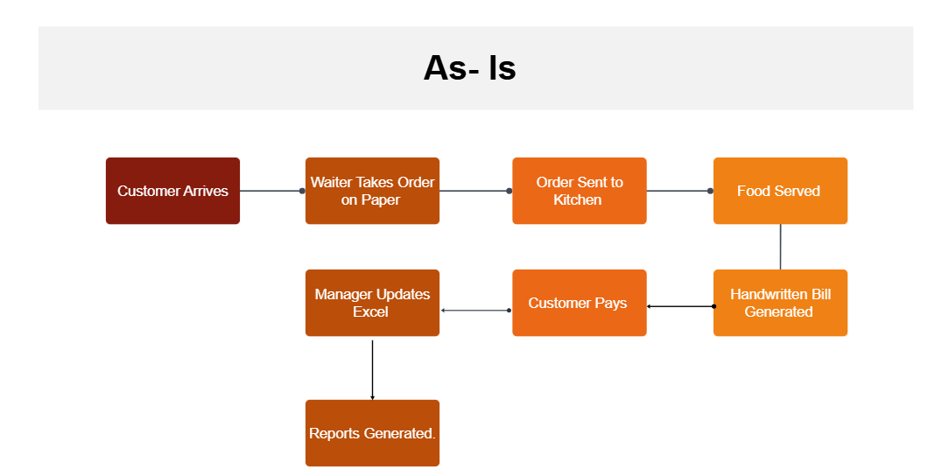

To-Be Process
The proposed RMS will digitize the entire workflow. Orders, billing, reservations, and reporting will be handled through a centralized system with role-based access.
To-Be Process Flowchart:
Customer Seated → Waiter Logs In → Order Entered in System → Bill Auto-Generated → Payment Processed → Sales Stored in Database → Real-Time Reports.
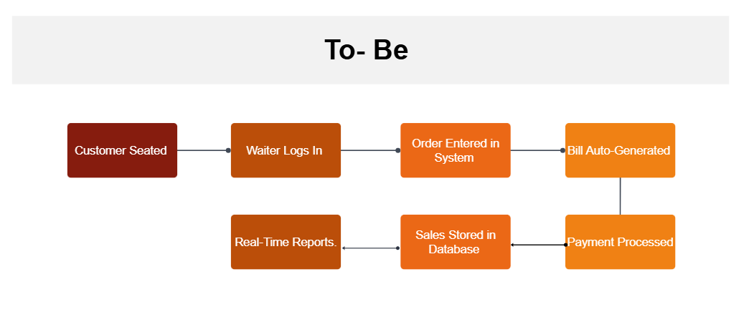
Scope Definition
In-Scope: Menu management, billing, reservations, reporting, payments, feedback management.
Out-of-Scope: Inventory management, HR/payroll, online ordering, mobile apps.

Business Requirements
Functional Requirements:
- Role-based login for managers, waiters, and CEO.
- Menu creation and maintenance by managers.
- Bill generation by waiters.
- Table reservation management.
- Automated sales reporting.

Non-Functional Requirements:
- Usability and performance.
- Security and data integrity.
- Scalability across cities.

Wireframe:
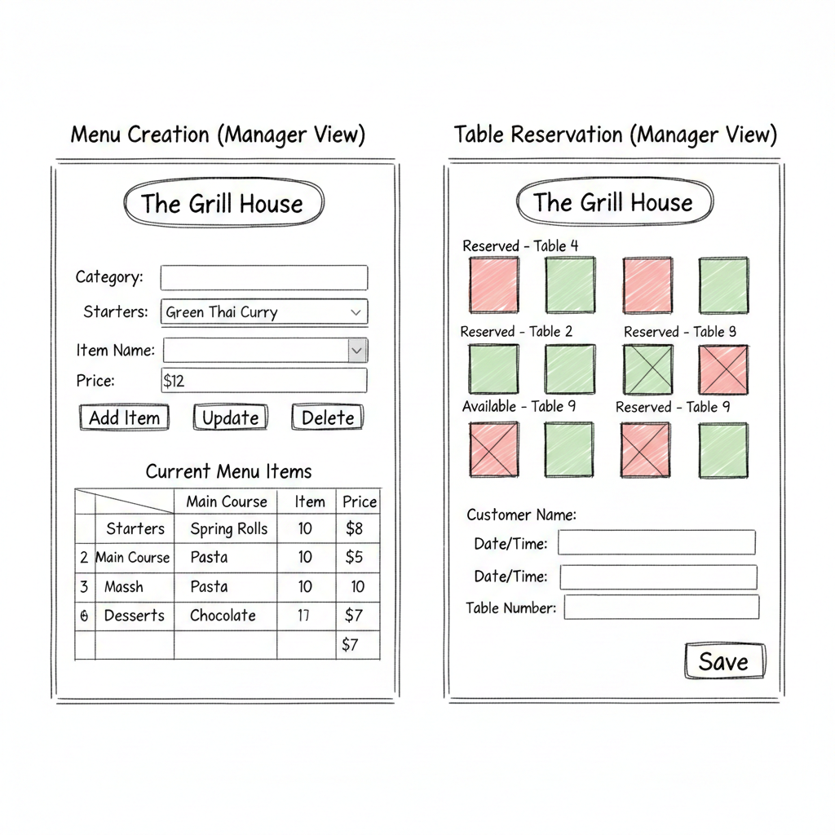

Product Backlog User Stories
- As a manager, I want to add menu items so that I can update the restaurant offerings.
- As a manager, I want to edit menu items so that I can correct prices or names.
- As a manager, I want to delete menu items so that I can remove discontinued dishes.
- As a waiter, I want to search menu items so that I can quickly find dishes while billing.
- As a waiter, I want to generate bills so that customers can pay for their orders.
- As a waiter, I want bills tagged with my ID so that accountability is maintained.
- As a manager, I want to reserve tables so that customers with bookings are accommodated.
- As a waiter, I want to view reserved tables so that I don’t seat customers incorrectly.
- As any user, I want to log in so that I can access the system securely.
- As any user, I want to change my password so that my account remains secure.
- As a manager, I want daily sales reports so that I can track performance.
- As a CEO, I want city-wise sales reports so that I can compare branches.
- As a manager, I want to see top 10 dishes so that I can plan menu improvements.
- As a manager, I want to enter customer feedback so that customer insights are stored.

Acceptance Criteria
User Story: Add Menu Item
Given I am logged in as a manager
When I enter item name, category, and price
And click “Add Item”
Then the item should be saved
And appear in the menu list.
User Story: Generate Bill
Given I am logged in as a waiter
When I select table number and items
And click “Generate Bill”
Then the system should create a bill
And tag it with my user ID and table number
And allow payment selection (cash/card).
User Story: Reserve Table
Given I am logged in as a manager
When I select a table and reservation time
Then the table should be marked as reserved
And visible to waiters as reserved.

Tableau:
Assumptions:
Sales data is captured daily for each restaurant. Data includes Date, City, Restaurant Name, and Sales Amount. Dashboard shows last 6 months of sales only. Sales amount is in USD. Data shown is mock data created for analysis purpose.

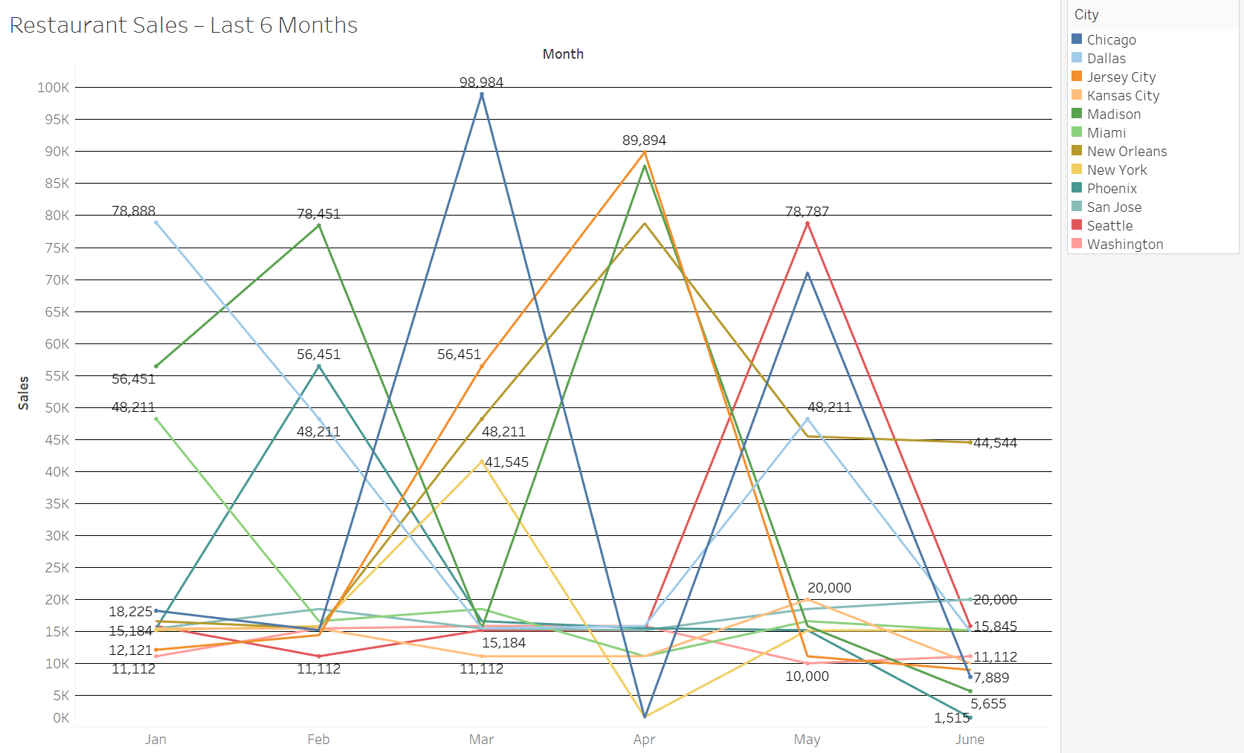
This is the screenshot of restaurant sales in last 6 months.

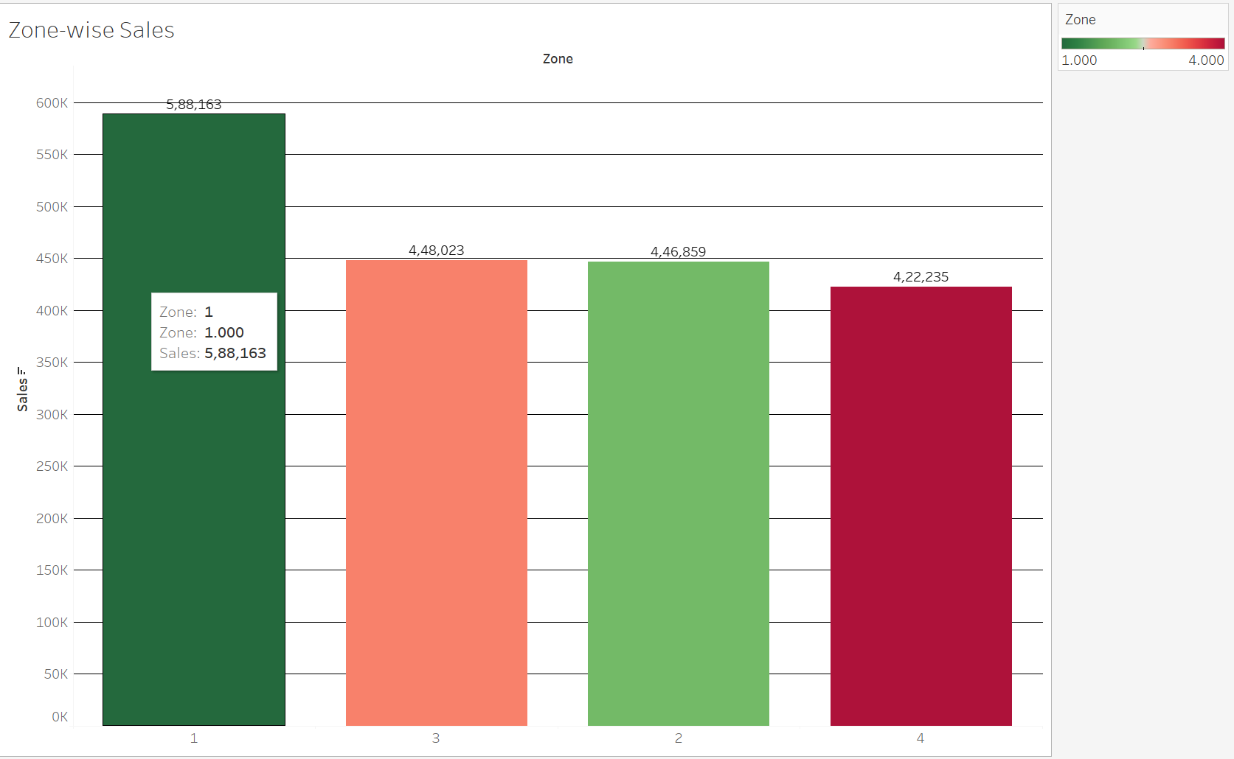
This is the comparison of zone wise sales.

Tableau dashboards were created using mock sales data to visualize restaurant performance.
The senior management dashboard shows sales trends for the last six months, while the zone dashboard highlights the zone with the highest sales. These dashboards help management make strategic decisions.

Excel
Bar graph for San Jose, Madison, and New York showing the sales

